Design and Implementation of a Simple Networking Project #1

**Project #1 Case Study and Requirements**  
Design a network in Cisco Packet Tracer to connects ACCOUNTS and DELIVERY departments through the following:

* Each department should contain at least two PCs.
* Appropriate number of switches and routers should be used in the network.
* Using the given network 192.168.40.0, all interfaces should be configured with correct IP addresses, subnet mask and gateways.
* All devices in the network should be connected using appropriate cables.
* Test communication between devices in both ACCOUNTS and DELIVERY departments.

**Technologies Implemented**

1. Creating a Simple Network using a Router and Access Layer Switch.
2. Connecting Networking devices with Correct cabling.
3. Connecting two Networks using a Router.
4. Subnetting and IP Addressing.
5. Assigning IP Addresses to Router's interfaces.
6. Static IP Address allocation to Host Devices.
7. Test and Verifying Network Communication.

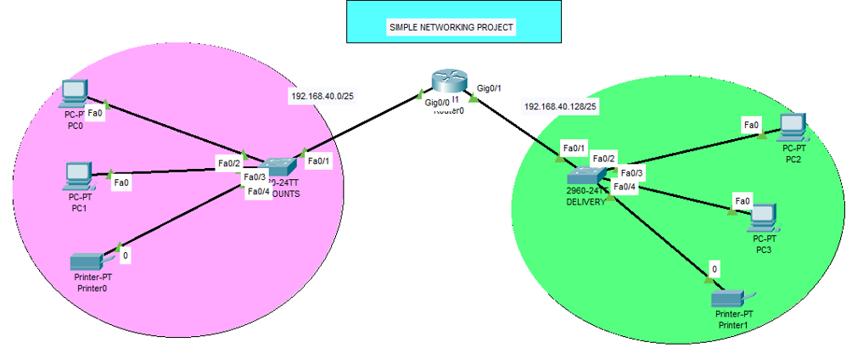**Network Topology Created**  
The network topology below satisfy the user requirements above and everything is verified, tested and working fine. You can get source file (Packet Tracer File)